# **Template – Enrollment Agreement**

The template named “Template – Enrollment Agreement” is applicable to CampusNexus Student.

## Purpose and Outcome

This template provides a form sequence and supporting workflow for an enrollment agreement to be submitted by an applicant. The sequence requires the following:

* A complete **Applicant Record** must exist in the CampusNexus Student database (any missing field, e.g., Grade level, could cause a failure in the workflow). In our example, we are using the “Pending Applicant” status.
* The applicant must have a **Portal login** to log into this authenticated sequence.

The template includes the steps required to collect **DocuSign** signatures/initials from the applicant and from a staff member.

Upon completion of the sequence, the student’s Applicant Record is converted to an Enrollment and the signed enrollment agreement (PDF) is added to the student’s document list in CampusNexus Student.

## Prerequisites

The template was built in Forms Builder using the applications listed below. The template is forward compatible with later versions of the listed applications.

|  |  |
| --- | --- |
| **Application** | **Minimum Version** |
| Forms Builder Designer and Renderer | 3.4 |
| Web Client for CampusNexus Student | 18.2 |
| Workflow Composer | 2.5 |
| Packages installed from Package Manager in Workflow Composer | Activities and Contracts (V1) 18.2.0  Activities and Contracts (V2) 18.2.0  Forms Builder Contracts 3.4 |
| Workflow Tracking Database | N/A |
| Staff STS 2.0 | 2.0 |

## Step 1: Download and Import the Template

1. Download the template file to your environment (local drive or network location).
2. Log into **Forms Builder Designer**.
3. Click the **Export/Import** tile.
4. Select the **Import** tab.
5. Click **Select exported file** and navigate to the downloaded template file.
6. Click **Import**.

* [Export/Import](https://help.campusmanagement.com/FB/3.x/Content/ExportImport.htm)

## Step 2: In Form Designer…

1. From the **Forms** slide out, select **Campus University – Enrollment Agreement**.
2. Customize the form for your environment. Modify properties on current fields to make them required, etc., or add/remove fields on form. Make sure you edit the text in the Labels and HTML controls as applicable for your institution.

* [Fields](https://help.campusmanagement.com/FB/3.x/Content/Fields.htm) and [Components](https://help.campusmanagement.com/FB/3.x/Content/Components.htm)

1. **Save** the form.
2. From the **Forms** slide out, select **Campus University – Enrollment Agreement Acknowledgements**.
3. Customize the form for your environment and save it.

## Step 3: In Sequence Designer…

1. Select **Campus University – Enrollment Agreement**.

The sequence contains the following forms:

* Campus University – Enrollment Agreement
* Campus University – Enrollment Agreement Acknowledgements
* Default Frame (This form is required when DocuSign is used for electronic signatures.)
* DocuSignWait (This form is required in sequences with multiple DocuSign signers.)

1. Click **Save As** to create a copy of the sequence/workflow and customize the copy for your use. This way you can always refer to the original sequence/workflow you downloaded.
2. Optional - Add a custom style (theme) associated with your campus.

* [Themes](https://help.campusmanagement.com/FB/3.x/Content/Themes.htm)

1. Select your sequence in the Sequences pane.
2. In the Properties Pane:
   * Ensure that the **Authentication Product** is **Student**.

* Select the **End State Form** named **Custom - Confirmation**.

1. **Save** the sequence**.**
2. Open the associated sequence workflow.

Depending on your environment, to open Workflow Composer either click **Open Workflow** in Sequence Designer or launch of a local installation of Workflow Composer.

* [Opening Workflows for Sequences](https://help.campusmanagement.com/FB/3.x/Content/HostedEnv.htm)

## Step 4 In Workflow Composer…

1. In the **Welcome** form/state, locate the **LookupReferenceItem** activity.

Verify that a Reference Item for **Enrollment Agreement** is found in your environment.

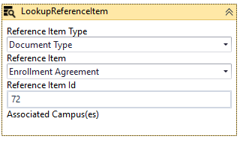

* [LookupReferenceItem activity](https://help.campusmanagement.com/WF/Content/Workflow/LookupReferenceItem.htm)

1. In the **Default-Frame** form/state, locate the **Assign Signer 2 Name** activity.

In the **Value** field, specify the name of the staff member that will be signing the enrollment agreements.

1. In the **Default-Frame** form/state, locate the **Assign Signer 2 Email** activity.

In the **Value** field, specify the email address of the staff member that will be signing the enrollment agreements.

1. In the final transition (labeled “Done”), in the **Condition** field, add the statement **signer2Complete.** This statement is excluded from the template to make it easier to test the sequence without having to wait for all signers to complete the DocuSign steps.

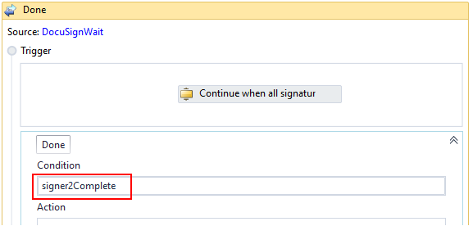

1. The final transition contains an **If** activity that checks if an enrollment agreement was found or created. Locate in the Ifactivity below the GetSignedDocument activity.

Make sure that the document **Status** property has the same value in both branches (Then/Else) of the If activity.

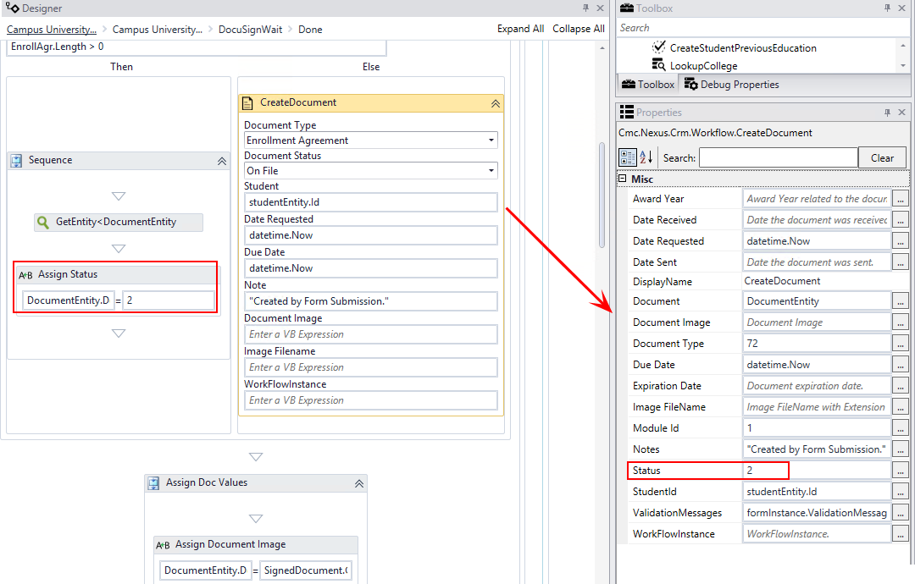

1. In the final transition, locate the **LookupReferenceItem** activity.

In the **Reference Item Type** field, select the **School Status** to be assigned after the ConvertApplicantToEnrollment activity is completed.

1. In the final transition, locate the **ConvertApplicantToEnrollment** activity.

In the **AcademicAdvisorId** field, specify the ID appropriate for your environment.

**Note**: The Academic Advisor ID in the template is hardcoded and must be updated.

If you are using Activities and Contracts for CampusNexus Student 19.0 (and later) **and** the user’s Academic Advisor has been assigned to the applicant, you can add the LookupAdvisor activity followed by an Assign activity to the workflow instead of hardcoding the AcademicAdvisorID value.

* [LookupAdvisor activity](https://help.campusmanagement.com/WF/Content/Workflow/LookupAdvisornew.htm)

## Step 5: In Forms Renderer and CampusNexus Student…

Select your sequence and try it out!

* [Sequence List](https://help.campusmanagement.com/FB/3.x/Content/SequenceList.htm)

1. Find your **Enrollment Agreement** sequence and copy the **URL** to the clipboard.
2. Log in to Portal as the **student** and complete the enrollment agreement sequence.
3. Verify that the **staff** member responsible for signing enrollment agreements received the email notification to complete the DocuSign steps.
4. In CampusNexus Student, verify the following:

* The enrollment agreement was added to the applicant’s document list and the PDF is viewable.
* The applicant’s status was updated.
* The applicant was enrolled in the selected program.

## Step 6: Lastly…

Once your updated sequence has been tested successfully, it is recommended that you disable the workflow for the original Template version.

1. In Workflow Composer, in the Server section of the ribbon, click **Open**.
2. Find the workflow named **Campus University – Enrollment Agreement**.
3. Clear the **Enabled** check box and click **Save**.